**ASSIGNMENT 2**

**Name:** Sudharsan Srinivasan

**UTA ID:** 1001755919

**Part 1- The Basic HTTP GET/response interaction:**

1. **Is your browser running HTTP version 1.0 or 1.1? What version of HTTP is the server running?**

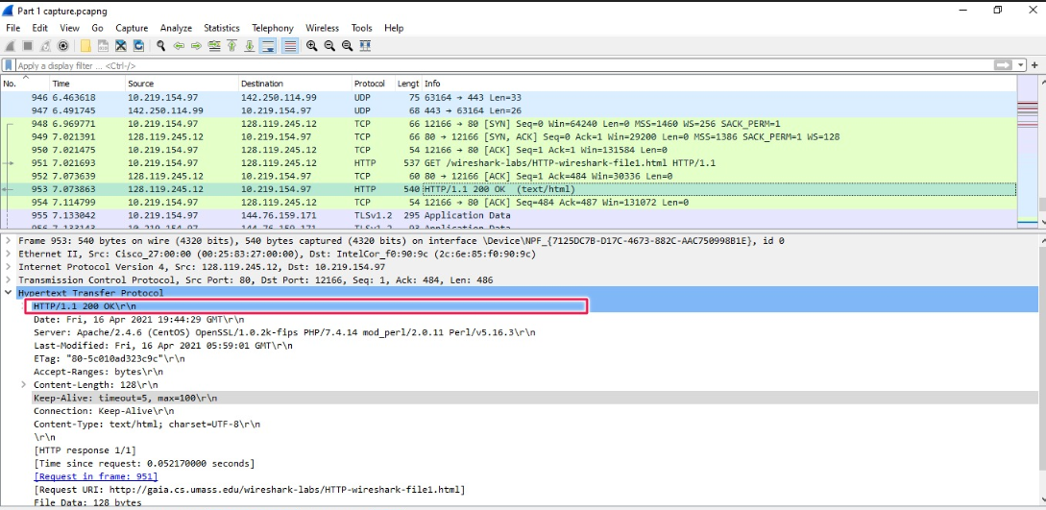

As seen in the above image, the browser is running in **HTTP version 1.1**

1. **What languages (if any) does your browser indicate that it can accept to the server?**

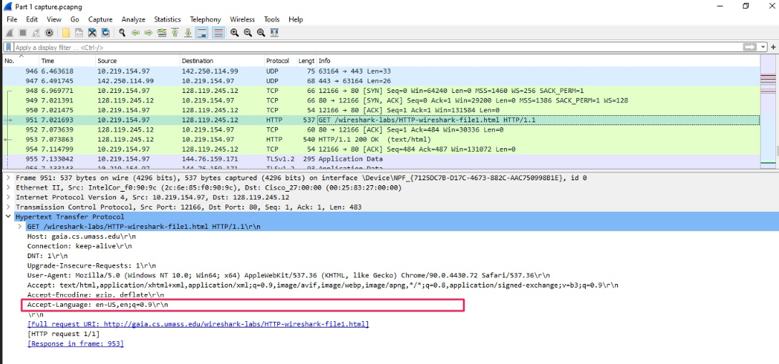

In the above image, it indicates that the accepted language to the server is **en-US**

1. **What is the IP address of your computer? Of the gaia.cs.umass.edu server?**

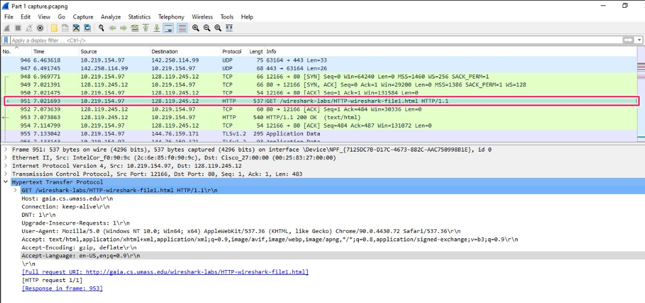

As seen above, the IP address of the computer is **10.219.154.97** and the address of gaia.cs.umass.edu is **128.119.245.12**

1. **What is the status code returned from the server to your browser?**

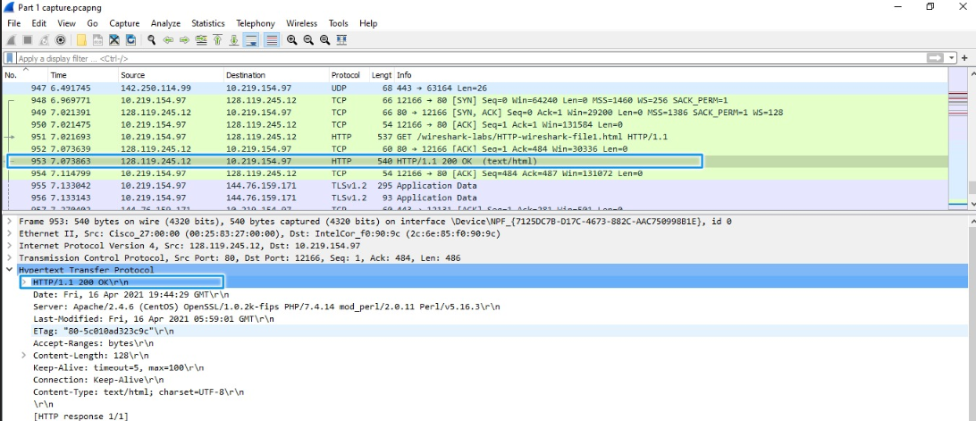

As indicated in the image above, the status code returned from the server to the browser for the file is **200 OK**

1. **When was the HTML file that you are retrieving last modified at the server?**

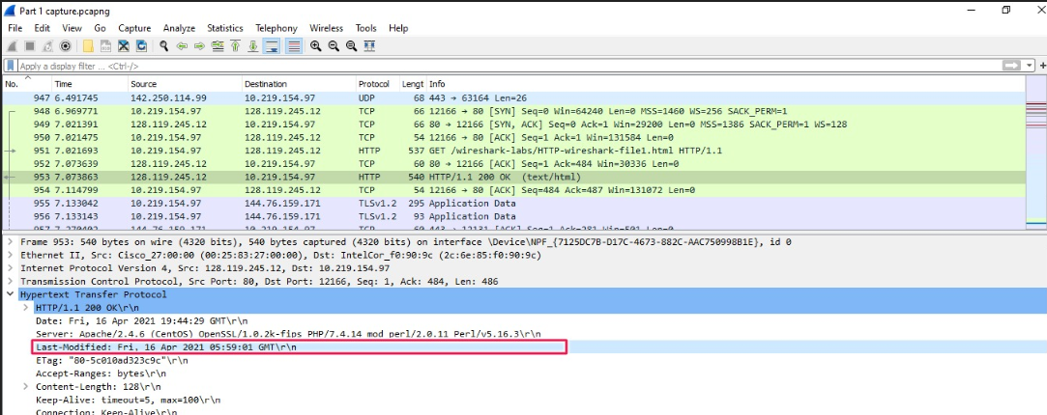

The HTML file was last modified on **Fri, 16 Apr 2021 05:59:01 GMT**

1. **How many bytes of content are being returned to your browser?**

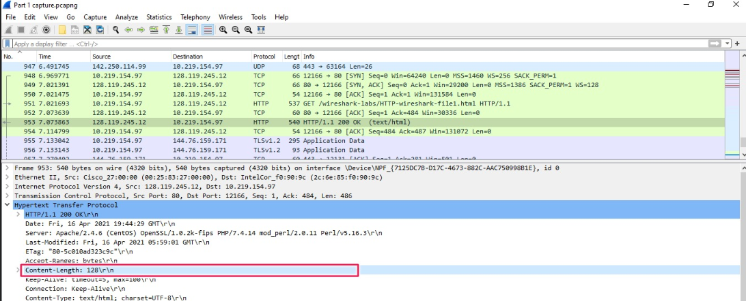

The content length contains **128 bytes** returned from the browser.

1. **By inspecting the raw data in the packet content window, do you see any headers within the data that are not displayed in the packet-listing window? If so, name one.**

**No.** There is no difference between the packet content and packet listing window.

**Part 2 - The HTTP CONDITIONAL GET/response interaction:**

1. **Inspect the contents of the first HTTP GET request from your browser to the server. Do you see an “IF-MODIFIED-SINCE” line in the HTTP GET?**

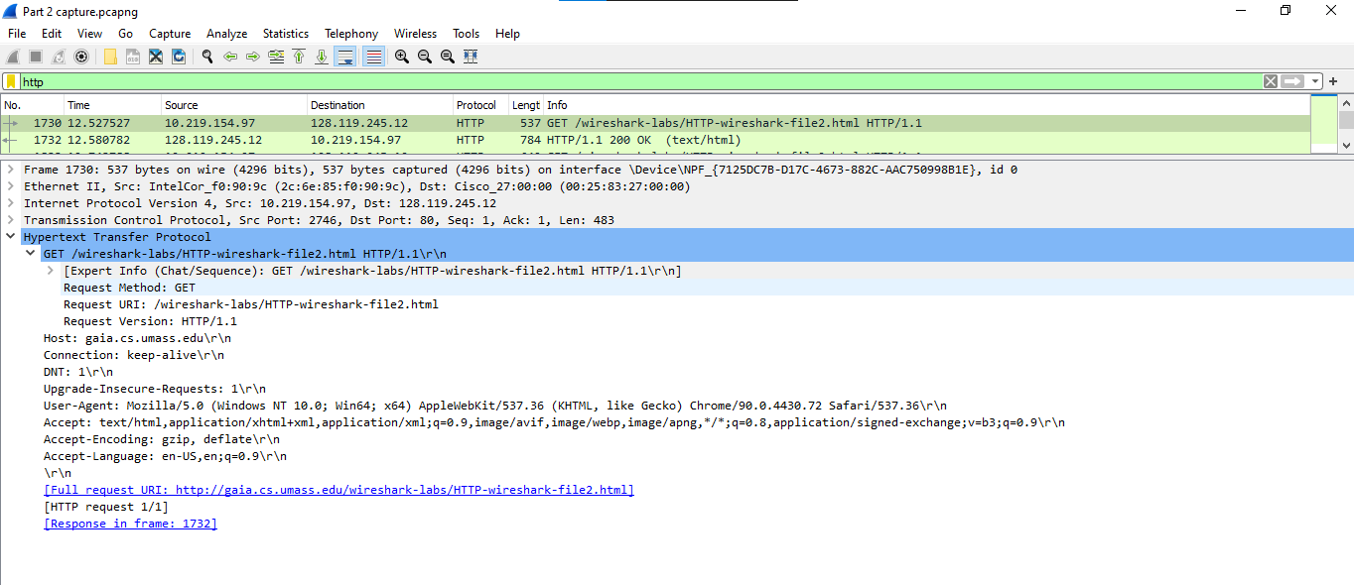

On inspecting the HTTP-wireshark-file2.html file, it can be seen that there is **NO** “IF-MODIFIED-SINCE” line in the HTTP GET.

1. **Inspect the contents of the server response. Did the server explicitly return the contents of the file? How can you tell?**

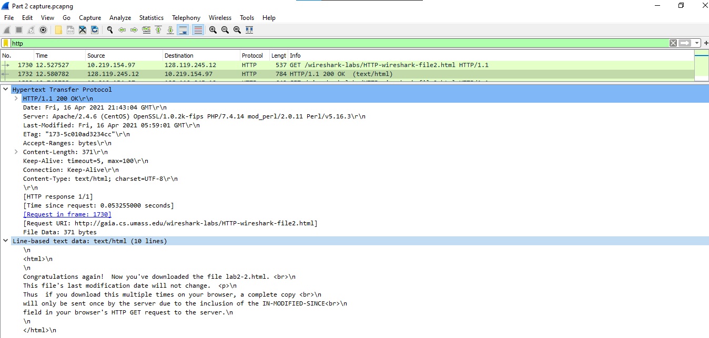

As seen in the above image, the contents of the file are explicitly returned in “**Line-based text data section**”

1. **Now inspect the contents of the second HTTP GET request from your browser to the server. Do you see an “IF-MODIFIED-SINCE:” line in the HTTP GET? If so, what information follows the “IF-MODIFIED-SINCE:” header?**

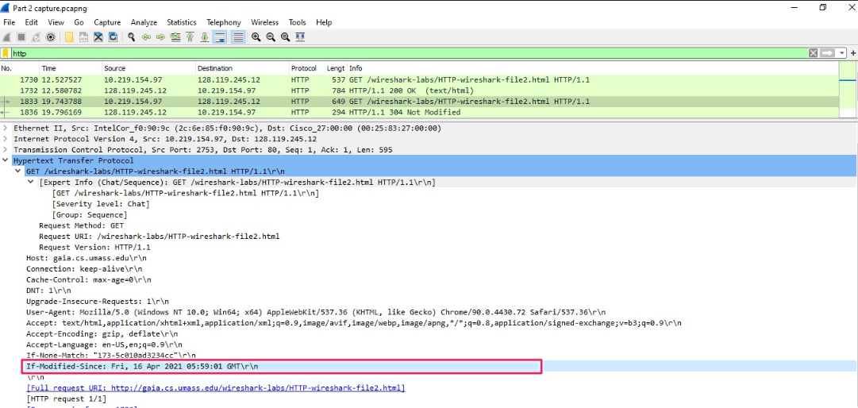

In the second GET Request, there is a new field that reads “**If-Modified-Since**” which gives the date and time of the file.

1. **What is the HTTP status code and phrase returned from the server in response to this second HTTP GET? Did the server explicitly return the contents of the file? Explain.**

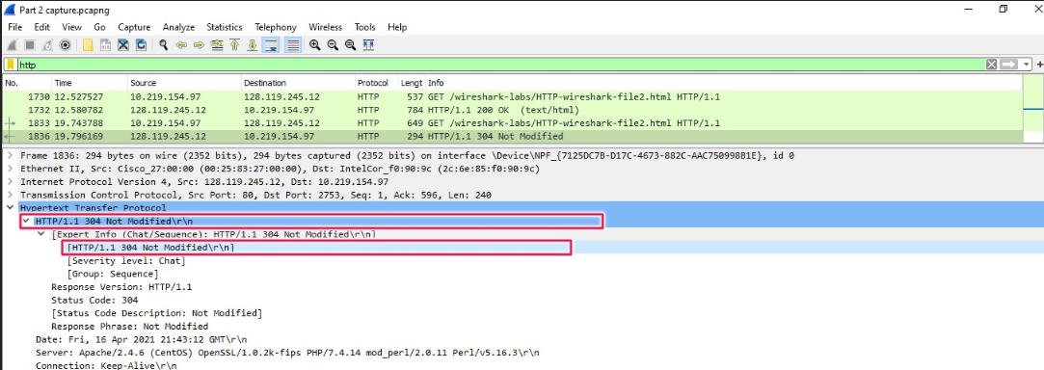

In the second HTTP request, the status code is “**304 Not Modified**”. This shows that the file has been retrieved from the cache of the local browser instead of the server, therefore it is not modified.

**Part 3 - Retrieving Long Documents:**

1. **How many HTTP GET request messages did your browser send? Which packet number in the trace contains the GET message for the Bill or Rights?**

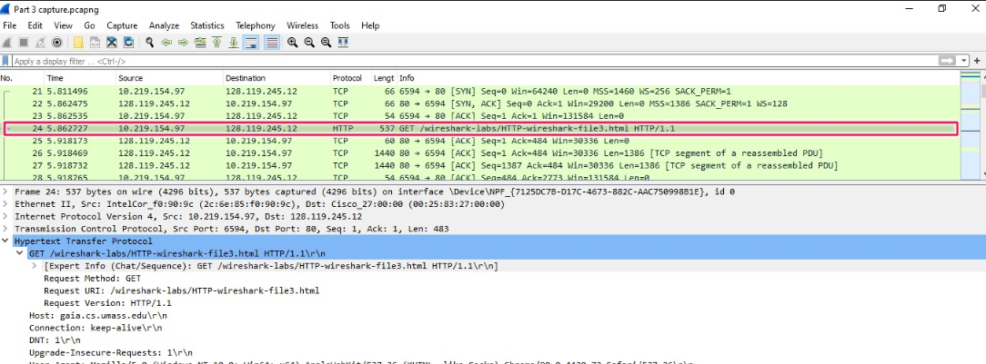

The browser send **1 HTTP GET request message** in total and the packet number **24** contains the GET message for the Bill or Rights.

1. **Which packet number in the trace contains the status code and phrase associated with the response to the HTTP GET request?**

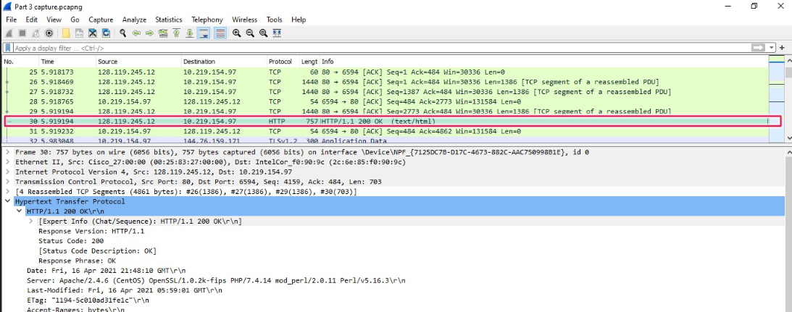

The packet number is **30** which contains status code and phrase associated with the response to the HTTP Get request.

1. **What is the status code and phrase in the response?**

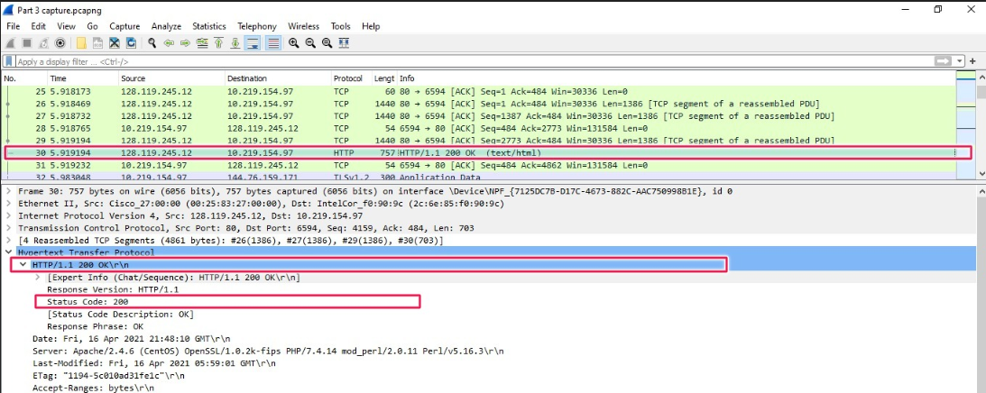

The status code for the file is **200** and the phrase is **OK** as seen in the highlighted areas in the image above.

1. **How many data-containing TCP segments were needed to carry the single HTTP response and the text of the Bill of Rights?**

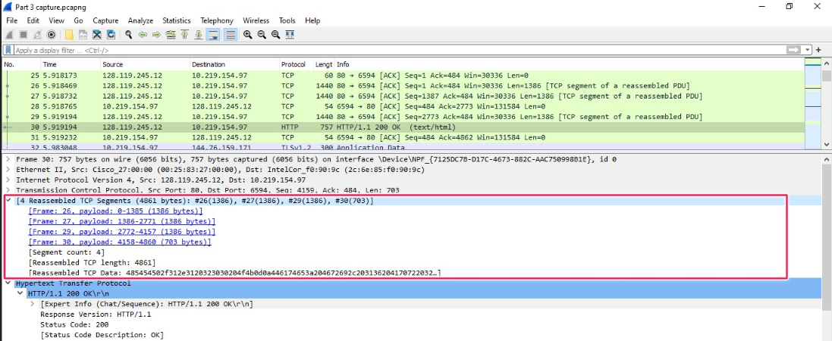

As seen above, the data was sent in **4 TCP Segments** to carry the HTTP response and then reassembled later.

**Part 4 - HTML Documents with Embedded Objects:**

1. **How many HTTP GET request messages did your browser send? To which Internet addresses were these GET requests sent?**

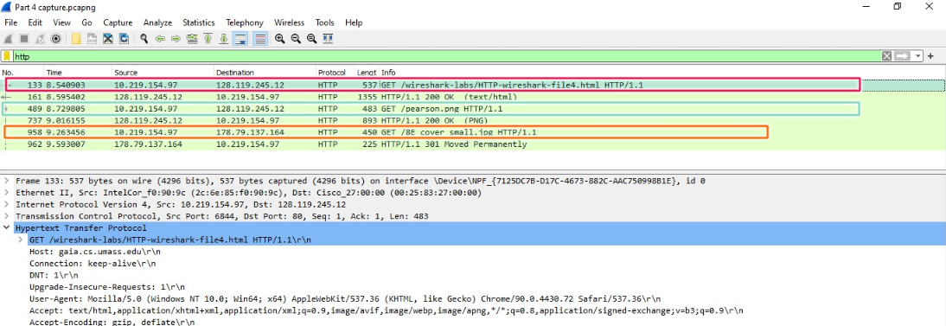

The browser sends 3 different GET requests:

• 1st GET : To get the page address: **128.119.245.12**

• 2nd GET : To get the Pearson logo: **128.119.245.12**

• 3rd GET : To get the Pearson Book Cover: **178.79.137.164**

1. **Can you tell whether your browser downloaded the two images serially, or whether they were downloaded from the two web sites in parallel? Explain.**



As seen from the above image, the requests for the two images are sent and downloaded serially one after the other. This can be seen above, where the GET request for **pearson.png** was sent and returned with status **OK,** followed by GET request for **8E_cover_small.jpg**.

The time for the 1st GET request is **8.729805** and for the 2nd request is **9.263456** indicating that the requests have been sent serially, one after the other.

**Part 5 - HTTP Authentication:**

1. **What is the server’s response (status code and phrase) in response to the initial HTTP GET message from your browser?**

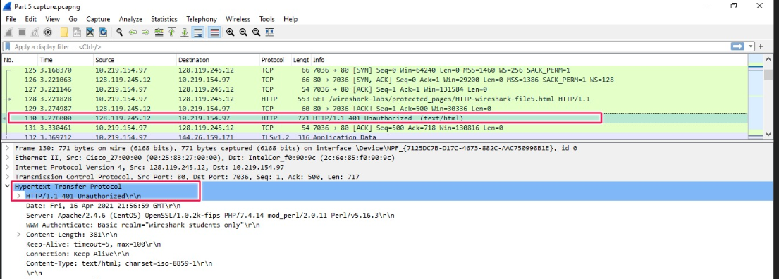

The server’s response to the initial HTTP GET message is **401 Unauthorized** because there is no username and password fields values for it to check and therefore the request/access is denied.

1. **When your browser’s sends the HTTP GET message for the second time, what new field is included in the HTTP GET message?**

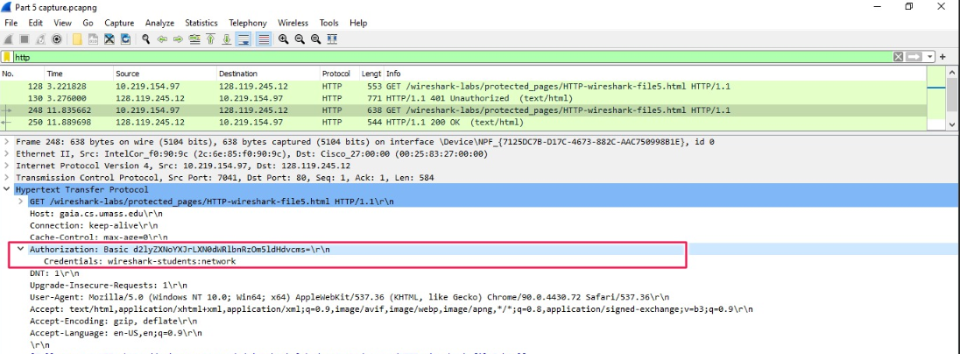

When the browser sends HTTP GET message again for the second time, there is a new field “**Authorization**” that gets included in HTTP. This field contains the credentials that we used for username and password field in the webpage.